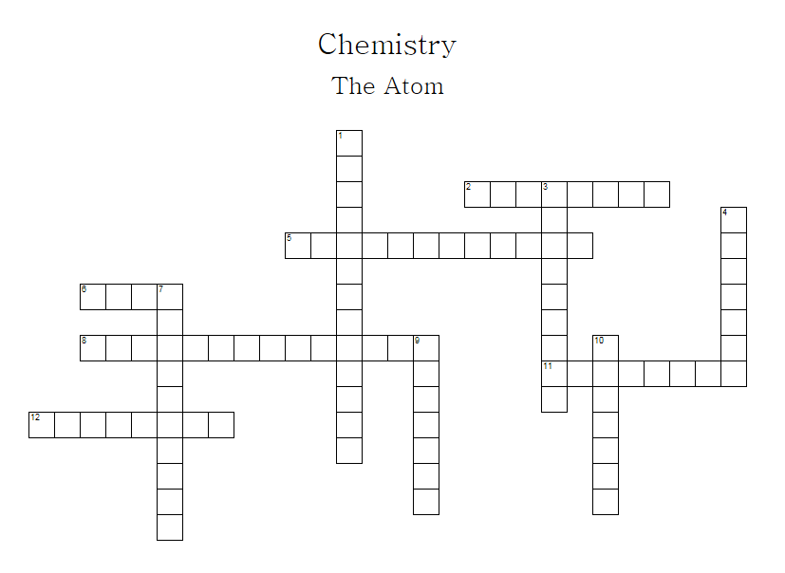
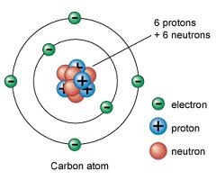
ACROSS
 | 2 | Formed when two or more atoms are joined together
 | 5 | Number of protons in an atom is equal to a number called the...
 | 6 | Element composed of one type, the...
 | 8 | A large grid-like structure formed when atoms stick together
 | 11 | Particles in an atom with no charge
 | 12 | A substance in which the atoms of two or more elements are combined
 | DOWN
 | 1 | A table filled with elements in order of their atomic number
 | 3 | 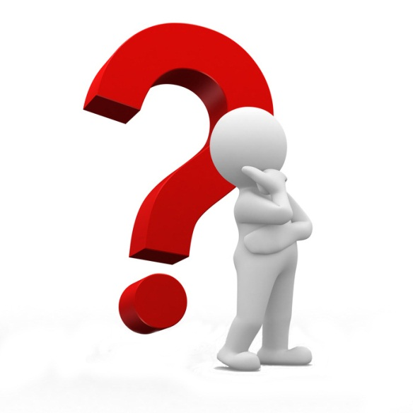  Particles with a negative charge
 | 4 | Particles in an atom with a positive charge
 | 7 | This number is the sum of the number of protons and neutrons
 | 9 | If all the atoms in a substance have the same identity, it is called an...
 | 10 | The centre of an atom

